Crypto Token $VAULT – Whitepaper



Disclaimer
This whitepaper is for informational purposes only and does not constitute financial, investment, legal, or gaming advice. VaultGames and its associated entities make no guarantees regarding the accuracy, completeness, or reliability of the information contained herein.
The content of this document is subject to change as the project evolves, and VaultGames reserves the right to modify any aspects of the platform, Tokenomics, or roadmap without prior notice. The represent equity, shares, security, or ownership in any entity.
Participation in the pre-sale, staking, or gaming activities on the platform carries inherent risks, including but not limited to market volatility, regulatory changes, smart contract vulnerabilities, and unforeseen technological issues. Users and investors should conduct their research and seek professional advice before engaging with VaultGames or purchasing $VAULT tokens.
VaultGames operates within the legal frameworks of relevant jurisdictions. However, regulatory compliance may vary based on location. Users are responsible for ensuring that participation in VaultGames and its services complies with the laws of their respective countries. VaultGames is not liable for any financial losses, security breaches, or legal issues arising from user participation in the platform.
By accessing and engaging with VaultGames, users acknowledge that they fully understand the risks associated with blockchain-based gaming and the DeFi industry. VaultGames, its team members, partners, and affiliates are not responsible for any direct, indirect, incidental, or consequential damages resulting from the use of this platform or reliance on the information provided in this whitepaper.

Summary
The rise of play-to-earn games became evident in 2021 when a gamer in the Philippines earned a full-time living through Axie Infinity, a blockchain-based P2E game. What started as a way to pass the time quickly became a lifeline for thousands of players. This shift reinforced the idea that gaming could go beyond entertainment and create real financial value.
Over the last couple of years, the gaming industry has shifted from traditional entertainment to an expansive ecosystem that drives empowerment, financial incentives, and true asset ownership. GameFi is leading the charge in this transformation while bridging gaming and DeFi to create player-driven digital economies.
GameFi leverages blockchain technology to create immersive ecosystems where players are no longer just participants but stakeholders. By integrating P2E mechanics, tokenized rewards, and true asset ownership through NFTs, GameFi has unlocked unprecedented opportunities for both gamers and investors.
The gaming market reflects this rapid expansion with the global GameFi sector expected to surpass $160.41 billion by 2033.
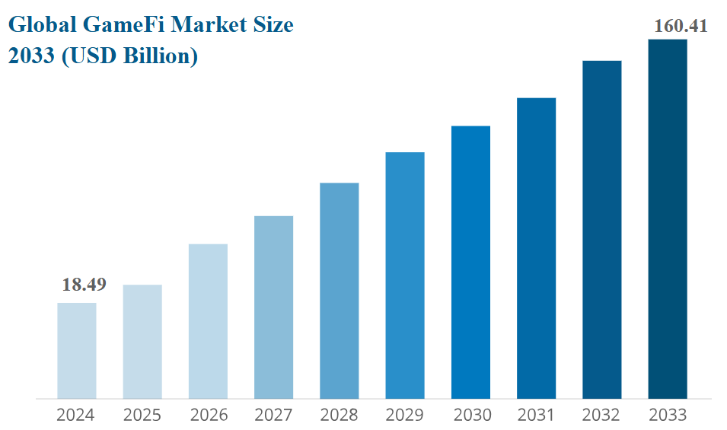

Unlike traditional gaming models that restrict users from monetizing in-game assets, GameFi enables players to trade, sell, and fully own their achievements in decentralized marketplaces. Additionally, its global accessibility removes geographical barriers while allowing anyone with an internet connection to participate and benefit from the ecosystem.
However, despite its potential, the GameFi industry faces key challenges, including trust deficits, inconsistent quality, and a lack of seamless integration between financial incentives and engaging gameplay.
VaultGames is designed to overcome these challenges by merging cutting-edge blockchain technology with engaging & high-quality gaming experiences. Positioned as a leading GameFi and crypto casino platform, VaultGames ensures transparency, security, and user-friendly interfaces while providing a trustworthy and rewarding environment for players.
With the gaming and blockchain industries evolving rapidly, VaultGames is pioneering the next era of decentralized entertainment and offering a groundbreaking solution for online gambling and blockchain-powered gaming. By combining innovation with a seamless user experience, VaultGames is the ultimate gateway to the GameFi revolution.
This whitepaper delves into VaultGames' vision, the challenges in the gaming industry, the utility of the Vault token, the underlying technology, and how it creates a seamless, rewarding, & decentralized gaming experience for players and investors.

Primary Challenges
There is no denying that the gaming industry has evolved significantly from classic arcade systems to immersive online experiences and blockchain-powered innovations. However, both traditional gaming and crypto casino platforms face several challenges that impact users, developers, and investors. Here are some crucial ones:

High Transaction Fees & Payment Barriers
Traditional gaming solutions charge high fees on in-game purchases, withdrawals, and asset sales. Many platforms rely on credit cards, bank transfers, or third-party payment providers, all of which come with high transaction fees. Withdrawals can take days or even weeks depending on the player's location and payment method.

Lack of Trust & Transparency
Traditional online casinos operate in a centralized environment where players have no way of verifying whether the games are truly fair. Many platforms manipulate the odds in their favor, and payout processes lack transparency. Crypto casinos often lack fair verification mechanisms, which makes them prone to fraud.

Limited Access to Global Markets
Many online gambling platforms are restricted by regional laws and banking regulations, which prevent users from participating based on their location. Some countries impose strict financial regulations which make it difficult for players to deposit or withdraw funds.

Security & Fraud Risks
Centralized gambling platforms are prime targets for cyberattacks, where hackers can steal funds or manipulate results. Users often have to trust a single entity to hold and protect their funds, which makes them vulnerable to fraud or bankruptcy risks.

P2W(Pay-to-Win) Models & Unfair Monetization
Many online casinos and GameFi platforms follow "pay-to-win" models, where players who spend more money have an unfair advantage. Additionally, traditional casinos often have low RTPs (Return to Players) which means the house takes a significant portion of player funds.
Who are VaultGames?
VaultGames is a blockchain-powered gaming platform that merges traditional online gambling with the latest advancements in the GameFi and DeFi sectors. Designed to overcome the limitations of traditional gaming and gambling platforms, VaultGames introduces fair play, reduced transaction costs, global accessibility, and true asset ownership.
With a native $Vault token, players and investors can engage in a thriving ecosystem where earnings are secure, provably fair gaming is ensured, and rewards extend beyond mere entertainment. VaultGames is built to meet the current & future demands of the gaming industry and ensure long-term value & innovation. It offers:
● A decentralized, transparent, and secure gaming experience
● Provably fair games built on smart contracts
● Exclusive in-house games designed to attract a large user base
● A community-driven ecosystem where players, developers, and investors interact seamlessly

Addressing Pay-to-Win Mechanics & Unfair Monetization
VaultGames introduces game mechanics that reward skill and strategy, rather than just spending money. Players earn rewards based on performance, engagement, and participation, rather than simply purchasing in-game advantages.
VaultGames offers higher RTP percentages than traditional casinos, meaning players receive more of their bets back over time. Transparent blockchain records ensure that no hidden manipulation of payout rates occurs in the platform.
Impact: Players of all financial levels can compete fairly, and winnings are more evenly distributed.

Creating a Sustainable & Community-Driven Ecosystem
VaultGames introduces a native token that allows players to earn rewards for gameplay and staking, participate in governance decisions, and access exclusive features & events. Players holding $Vault tokens can vote on certain platform upgrades, some new game features, and some economic policies. A player-first approach ensures long-term engagement and sustainability.
Impact: Players and investors are not just participants, but stakeholders in VaultGames' success.

Enhancing Security & Preventing Fraud
At VaultGames, security is a fundamental priority. The platform is built to ensure that users can play, earn, and interact within a safe and transparent environment. Here are some core security features:

KYC (Know Your Customer) Compliance
To maintain a secure environment and comply with regulatory standards, VaultGames enforces KYC protocols. By verifying user identities, the platform reduces the risks of fraudulent activities such as money laundering and unauthorized access.

Smart Contract Audits
All smart contracts within VaultGames undergo rigorous audits by trusted third-party security firms. These audits identify and eliminate potential vulnerabilities to ensure the reliability of transactions, reward distributions, and other automated operations.

Data Encryption
VaultGames utilizes advanced encryption protocols to protect user data. Sensitive information, including personal and financial details, is secured against unauthorized access, which reduces the risk of breaches or leaks.

Multi-Layer Authentication
To further enhance account security, VaultGames implements multi-layer authentication, including 2FA (Two-Factor Authentication). This additional security layer prevents unauthorized access to user accounts and digital wallets.

DDoS Protection
To ensure uninterrupted gaming experiences, VaultGames employs sophisticated DDoS (Distributed Denial of Service) protection techniques. These measures prevent malicious attacks aimed at disrupting platform operations.

Secure Wallet Integration
Users can seamlessly and securely generate their preferred cryptocurrency wallets inside VaultGames. This allows users to retain full control of their digital assets while interacting with the platform and depositing crypto without compromising security of their personal wallets.
Impact: Players never have to worry about platform hacks or fraud as their funds and bets are protected by blockchain security.

Mission & Vision

Mission Statement
VaultGames is created with a mission to empower players, investors, and developers with a secure, trust less, and rewarding gaming experience while eliminating traditional industry challenges such as lack of transparency, high fees, and limited accessibility. Through cutting-edge innovation, community-driven governance, and seamless integration of GameFi & crypto casinos, the platform aims to redefine the way the world interacts with digital gaming.

Vision Statement
VaultGames envisions a future where gaming is not just entertainment but a gateway to financial freedom and digital ownership. The platform is created with a vision to provide an ecosystem where every player has control over their assets, every transaction is trust less, and every bet contributes to building a legacy. Through continuous innovation, exclusive in-house games, and sustainable Tokenomics, VaultGames will set the standard for the next era of online gaming.

Scope of VaultGames
The scope of VaultGames extends beyond being just another crypto casino. It is a comprehensive GameFi and gambling ecosystem that prioritizes fairness, accessibility, and user empowerment. Through its core modules, VaultGames ensures an unparalleled gaming experience that is both profitable and enjoyable for players, investors, and developers alike.

Core Modules of VaultGames

❖ Crypto Casino / Sportsbook / Poker Client
At the heart of VaultGames lies its crypto-powered casino which offers a diverse range of games, betting opportunities, and interactive experiences. Unlike traditional online casinos that operate on centralized servers, VaultGames leverages blockchain technology to ensure:
➔ Provably fair gaming where results are transparent and verifiable.
➔ Instant and secure payouts using smart contracts.
➔ Anonymity and privacy, which eliminates the need for invasive KYC procedures in most jurisdictions.
➔ Borderless access to help users from different countries participate without restrictions.

❖ $VAULT Token
$VAULT token serves as the foundation of the VaultGames ecosystem, powering transactions, rewards, and governance. By integrating DeFi mechanisms, the platform enables:
➔ Low-cost and instant transactions to eliminate high fees associated with fiat-based gambling platforms.
➔ Staking & yield farming opportunities to allow users to generate passive income.
➔ A decentralized reward system to ensure fair distribution of winnings and incentives.
➔ A community-driven governance model, where token holders influence platform upgrades and policies.

❖ Digital Ownership
VaultGames embraces non-fungible tokens NFTs to provide players with true digital ownership over in-game assets. Unlike traditional games where items are locked within the platform, VaultGames allows:
➔ Players can buy, sell, and trade in-game assets across decentralized marketplaces.
➔ Customization and personalization of gaming experiences through unique NFT-based items.
➔ Interoperability and make sure that NFTs are used across multiple games in the ecosystem. Secure Blockchain Infrastructure

Trust issues plague the traditional gaming and gambling industry, where manipulation, delayed payouts, and opaque operations create a negative experience for users. VaultGames solves this through:
➔ Smart contract-based transactions to ensure tamper-proof and automated execution of bets.
➔ Decentralized RNG (Random Number Generator) to guarantee fair gameplay.
➔ Real-time audits and public ledger transparency to remove any possibility of fraudulent activities.

❖ Exclusive Blockchain-based Games
Beyond offering traditional casino games, VaultGames is developing its own exclusive blockchain-based games. These games are specifically designed to attract a vast user base while incorporating play-to-earn mechanics, NFTs, and GameFi elements. This ensures that:
➔ Players earn real rewards rather than just spending money.
➔ Games remain engaging and dynamic.
➔ The platform grows sustainably with an evolving ecosystem of in-house developed games.

Stakeholder in VaultGames
VaultGames will differ from other Crypto Casinos / Crypto Sportsbooks by offering $VAULT holders a quarterly dividend from the company's GGR (Gross Gaming Revenue). The dividend size will be decided by VaultGames board, no later than the 15th the following month and paid in $VAULT to the holders’ wallet automatically no later than the 20th the following month of the quarter it is calculated from.

Dividends will only apply to tokens held in wallets and under staking. The holder at midnight CET (Central European Time) at the end of quarter (31st March, 30th June, 31st September, 31st December) receives the dividend in his / her wallet. $VAULT held in a vesting program or under a cliff by the end of the last day CET (Central European Time) of the quarter are exempt for dividends. Tokens released from cliff or vesting during the quarter of calculation are fully approved for dividends.

Dividends paid for $VAULT under staking will be available for the holder immediately.

The dividend decided by VaultGames board is divided on the total amount of $VAULT liable for dividends. However, $VAULT in the staking program will be extra rewarded. $VAULT in a 3-month staking program will count 1,25 times in the allotment of the dividend, and if they are in a 12-month staking program it will count 2,00 times during the allotment.

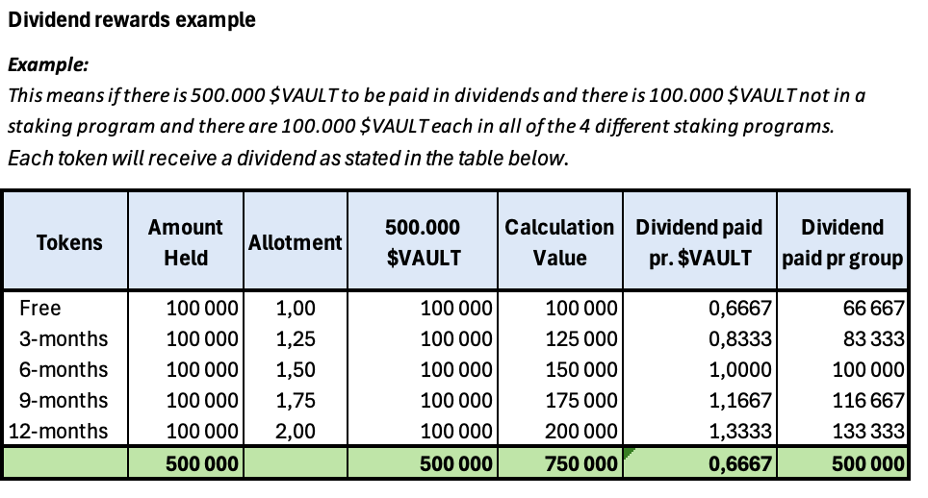

VaultGames Igaming Platform
VaultGames acknowledges the necessity of a comprehensive, robust and experienced software partner to run our gaming operations with. VaultGames will enter an agreement with one of the major companies in the world (TBD) running Igaming platforms. VaultGames has decided to run on a turnkey solution where SAAS (Software as a service) is essential. Our partner will deliver managed services in risk management, casino management, sportsbook management and customer support in several languages. In addition, the platform will provide a top tier multi-level affiliate system which handles both B2B operations and B2C operations across different brands and games. VaultGames will partner with top influencers and affiliate networks to expand our reach and make sure VaultGames quickly becomes a household name when it comes to online gaming. VaultGames already has agreements with some of the top sports influencer personalities. All $VAULT holders will be encouraged to participate in the affiliate program where they quickly can earn significant income on marketing the VaultGames brand.
The affiliate program will also be the place where $VAULT holders will receive their “Rakeback”. The Rakeback is only for $VAULT holders and only applies to gaming operations where $VAULT has been used as the gaming currency. See the Rakeback program for more information.
VaultGames platform will include an excellent CRM system to make sure we are in touch with our players to make sure they receive our very competitive bonus offers, campaigns and of course all necessary news about upcoming events, tournaments, jackpots etc. The CRM system will utilize AI features to interact with our players for retention and reduced churn.
The platform will have an AI driven bonus engine to make sure our players have the best possible offers in the market at any time and the most frequent ones.
In Igaming and Crypto there is always the threat of fraud, hacking and illegal activity. VaultGames platform will have a sophisticated 2FA security system, with fraud surveillance controlling all payments in and out. VaultGames takes security to a new level and will be one of the most secure online gaming sites ever.
VaultGames platform will have a significant number of payment methods and will support around 20 crypto currencies including $VAULT as gaming currencies. $VAULT will be accepted in the casino & sportsbook from day one, but it will take some time to get it implemented with all our gaming providers. In such cases you can easily exchange it into another currency.

VaultGames Sportsbook
The platform will deliver a state-of-the-art sportsbook which features like jackpots, bet-builder, buy-out, partial buy-out, personalization, AI-tools, odds-boost and more. VaultGames sportsbook will offer more than 100.000 live events and 100.000 pre-events.
The sportsbook will have native language and a native modern layout.
In VaultGames you will find great prizes, odds and a number of competitions in addition to traditional odds betting. VaultGames will deliver every sport available, and many of them live streamed on VaultGames.com
VaultGames sportsbook will be available from day one, and will be available on desktop, mobile, web mobile, Android and iOS.

VaultGames “Global Fan Gaming Community”
VaultGames is building a community utilizing sports influencers with social media networks in the size of millions. VaultGames will have co-branded sites connected with fan channels to all Premier League clubs and later all top 5 leagues in Europe. The network owners become co-owners in subsidiaries of VaultGames, where they in addition earn affiliate income on customers signing up through their commercial tags. This will create a snowball effect and attract more and more social media platforms connected to the fan base of the same club.
VaultGames expects a growth rate never before seen in Igaming when we release the gaming operations for subsidiaries in Q4. So far one of the largest networks in a top 5 club has signed a contract with us and we are in discussions with 12 more as of 25th May 2025. Including networks connected with all the top 6 clubs in the Premier League.

VaultGames Casino
VaultGames will have a top tier Casino from day one. Delivering everything you need and up to 20.000 games from the world leading suppliers like Evolution and Pragmatic, but also our own unique games. Our catalogue will continue to grow with VaultGames.
VaultGames will have everything anyone would need from a casino like slots, crash games, table games, card games, roulette, craps, blackjack and poker.
VaultGames will also have a fully live casino offering broadcasted casino with real croupiers at the roulette, craps or card table.

VaultGames Poker
The poker client will be an important part of VaultGames. It´s not quite ready, but hopefully it will be in place shortly.
VaultGames Poker Client will offer a vast number of tournaments with a wide spread of limits and buy-ins where everyone will find tournaments suited for their own playing experience.
The poker client will hold every known poker game and both tournaments and cash games. There will be free money tournaments and a lot of fun.
If you are a $Vault holder, a $VAULT staker or an affiliate you will be able to host your own tournaments where you can invite friends and partners.

VaultGames Rakeback
Rakeback to players participating in gaming utilizing $VAULT as their gaming currency
Rakeback is essentially the rebate VaultGames offers our stakers and $VAULT holders. The percentage you reach in a calendar month represents the rebate given to the player.
If you utilize $VAULT as your gaming currency, VaultGames will give you a Rakeback according to the table below on a calendar monthly basis.
*NB! There will not be duplicate Rake backs for players participating both in the Staking Program and utilizing $VAULT as their gaming revenue. VaultGames will payout whichever program giving the player the highest payout for the previous calendar month. However, if your gaming activity reaches level 9, and you participate in both programs, VaultGames will increase the Rakeback with 1,00 % (points)

Level | Monthly $VAULT in gaming – Requirement by player | Rakeback
1 | 30.000 | 1.00 %
2 | 60.000 | 1.50 %
3 | 90.000 | 2.00 %
4 | 120.000 | 2.50 %
5 | 150.000 | 3.00 %
6 | 180.000 | 3.50 %
7 | 210.000 | 4.00 %
8 | 240.000 | 4.50 %
9 | 270.000 | 5.00 %

Technology
VaultGames is built on a robust and scalable technology stack designed to deliver security, transparency, and efficiency in crypto gaming. Below is a detailed breakdown of the technology powering VaultGames and how each component contributes to its performance, security, and user experience.

Blockchain: Base
VaultGames leverages the Base blockchain, a layer 2 network that significantly reduces transaction costs while maintaining Ethereum’s security and decentralization. The platform benefits from Base’s rollup technology, which processes transactions off-chain before bundling them onto Ethereum.
This drastically lowers transaction fees, a crucial feature for a gaming platform where frequent transactions occur, such as bets, rewards, and withdrawals. By reducing fees to a fraction of traditional Ethereum costs, Base ensures that users enjoy a smooth and affordable gaming experience, free from excessive gas fees that typically burden blockchain-based casinos.

Why Base?
● Scalability & Cost Efficiency: Base significantly lowers gas fees compared to Ethereum by bundling multiple transactions off-chain before settling them on the Ethereum mainnet.
● Security & Trust: Built on Ethereum’s robust infrastructure, Base inherits its security model and ensures the highest protection for financial transactions and smart contracts.
Smart Contract Automation: Eliminates intermediaries and enables provably fair gaming, instant payouts, and transparent gameplay through automated smart contracts.
● Decentralization & User Control: Unlike centralized gambling platforms, Base allows users to have full control over their funds, bets, and gaming assets.
● Seamless Web3 Integration: Being part of Ethereum’s ecosystem, Base enables easy compatibility with wallets, decentralized exchanges, and NFT marketplaces.

Token Standard: ERC-20
$VAULT is designed following the ERC-20 token standard on Ethereum to ensure high security, broad compatibility, and efficient transaction processing. The token serves as the primary currency within the platform to enable transactions, staking, rewards, and governance.

Why ERC-20?
● Security & Reliability: Built on Ethereum’s trusted framework to ensure stability and resistance to attacks.
● Fast & Cost-Effective Transactions: Enables instant payouts, deposits, and rewards using smart contracts.
● Seamless Wallet Integration: Compatible with MetaMask, Trust Wallet, and other ERC-20 supporting wallets.
● Governance & Staking: Token holders can participate in decision-making processes and stake tokens for passive rewards.

Front-End Development: ReactJS
The front-end of VaultGames is designed using ReactJS to ensure a smooth, fast, and interactive user experience. As one of the most popular JavaScript libraries, ReactJS enables efficient rendering, scalability, and responsiveness.

Why ReactJS?
● Fast & Efficient Performance: ReactJS uses a Virtual DOM to ensure high-speed rendering and smooth animations.
● Responsive UI: Provides seamless gaming experiences across desktops, tablets, and mobile devices.
● Scalability & Modularity: Allows continuous improvements and feature expansions without disrupting the user experience.
● SEO-Friendly & High Performance: ReactJS optimizes page load times which makes VaultGames more accessible worldwide.

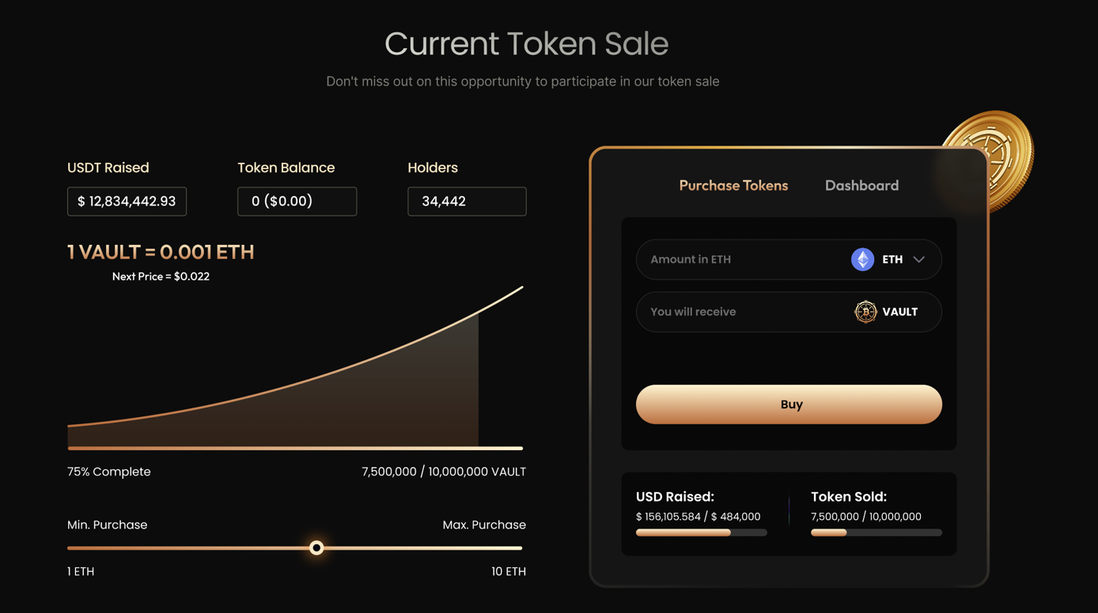

Back-End Web Services: Node.js
The back-end infrastructure of VaultGames is powered by Node.js, a high-performance JavaScript runtime. Node.js ensures real-time processing of gaming transactions, bet placements, and instant payouts.
Why Node.js?
● Real-Time Data Processing: Ensures instant bet settlements, fast gameplay, and immediate transaction updates.
● Scalability: Handles thousands of concurrent users without performance degradation.
● Asynchronous & Event-Driven: Optimized for fast event processing, crucial for high-speed casino gaming.
● Seamless API Integration: Easily connects with blockchain networks, payment gateways, and third-party services.

Database Management: MySQL
VaultGames utilizes MySQL 8.0+ as its primary database management system. While core financial transactions occur on the blockchain, MySQL efficiently manages user profiles, gaming history, leaderboards, and analytics.

Why MySQL?
● Fast Query Execution: Ensures instant access to player data, game results, and token balances.
● Data Consistency & Reliability: Guarantees accurate record-keeping of gaming activities.
● Secure & Scalable Storage: Protects user credentials, game analytics, and leaderboard rankings.
● Optimized Performance: MySQL’s high-speed indexing and caching mechanisms enhance overall platform efficiency.

Role of MySQL in VaultGames
● User Profile Management: Stores account details, gaming stats, and reward balances.
● Game & Bet Tracking: Logs real-time betting data and historical transactions.
● Leaderboard & Rewards System: Tracks top players, winnings, and bonus distributions.

Tokenomics
VaultGames' Tokenomics is designed to ensure the long-term sustainability, utility, and adoption of the Vault Token ($VAULT). As the core utility token of the VaultGames ecosystem, $VAULT facilitates transactions, rewards, staking, governance, and in-game interactions to provide a decentralized, fair, and rewarding gaming experience.

Total Token Supply & Purpose
● Total Supply: 5.000.000.000 VAULT Tokens
● Purpose: VaultGames' token distribution strategy is carefully structured to optimize long-term value, community participation, and platform expansion while maintaining a strong and sustainable economic model.

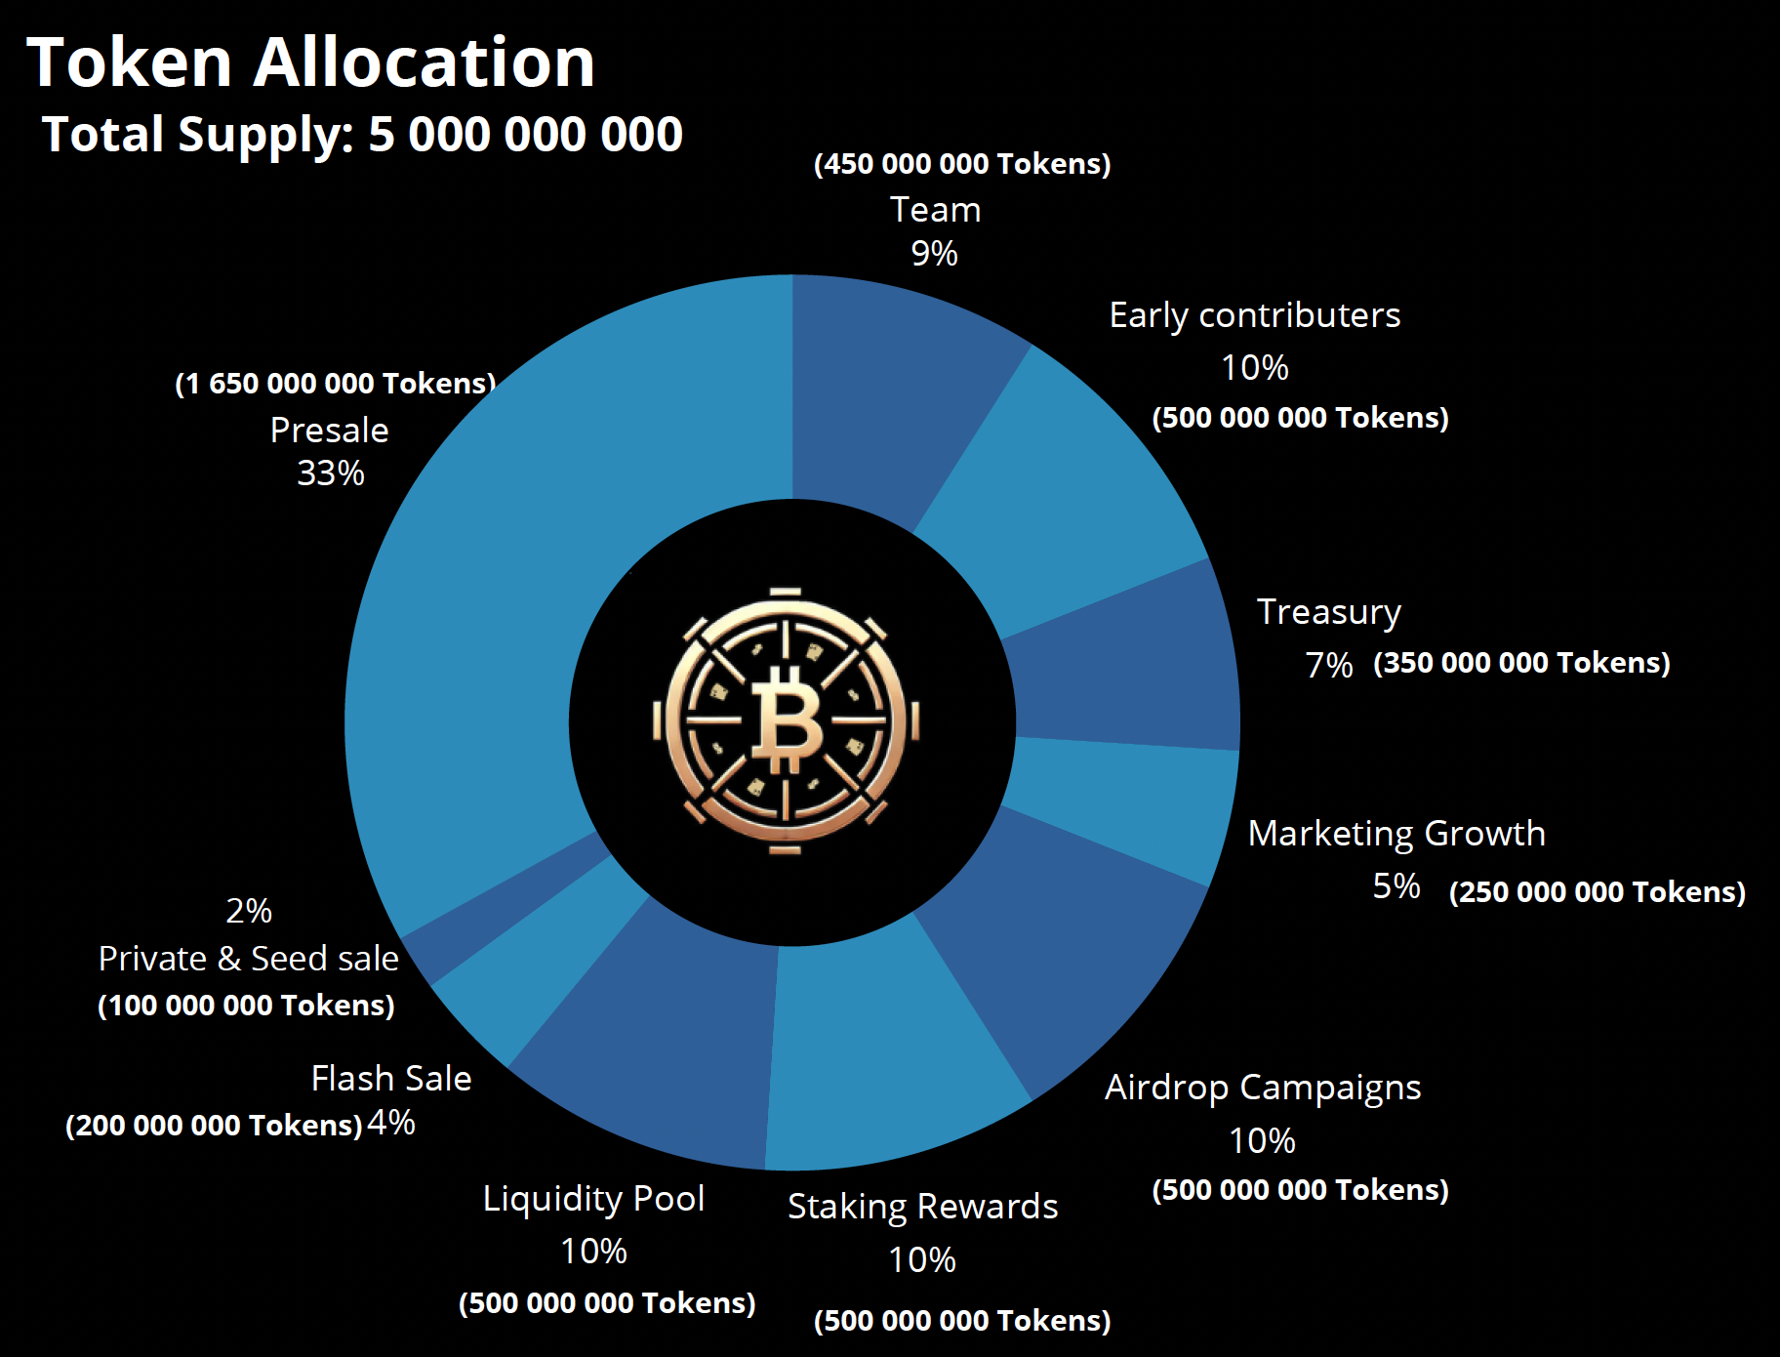

Key Token Allocations & Their Strategic Roles
★ Treasury
Allocation: 350.000.000 VAULT Tokens (7% of total supply)
The VaultGames treasury is a critical financial reserve, designed to provide long-term stability, liquidity, and strategic growth for the platform. It acts as a safeguard against market volatility while funding key initiatives, including:
● Liquidity Support: Maintains healthy market liquidity and ensures smooth and stable token trading.
● Strategic Partnerships: Collaborations with leading crypto gaming projects, blockchain platforms, and industry influencers.
● Platform Development: Supports continuous innovation in game mechanics, blockchain integrations, and user experience enhancements.
● Community Incentives & Governance: Encourages active participation through rewards, governance mechanisms, and user-driven decisions.

How Treasury Funds Enhance the Ecosystem?
● Ensures sustainable operations and project longevity.
● Provides a financial cushion for market downturns or unexpected expenses.
● Enables VaultGames to scale efficiently and attracts more players & investors.

Why Does It Matter?
The treasury ensures economic stability, fosters innovation, and strengthens VaultGames' position in the blockchain gaming industry.

★ Marketing
Allocation: 250.000.000 VAULT Tokens (5 % of total supply)
To establish VaultGames as a leading crypto casino and sportsbook, a strategic portion of the token supply is allocated to marketing and community expansion.

Key Marketing Strategies
● Influencer & Affiliate Marketing
➢ VaultGames will collaborate with top crypto influencers, gaming experts, and sports celebrities to expand its global reach.
➢ The existing network of sports influencers will help attract players worldwide.

● Community Engagement & Player Incentives
➢ VaultGames will introduce exclusive tournaments, giveaways, loyalty programs, and cashback policies to retain players.
➢ Free tutoring programs will be offered to skilled players to encourage long-term engagement and platform loyalty.

● Paid Advertising & SEO
➢ Data-driven ad campaigns to enhance brand awareness and drive organic traffic.
➢ Targeted SEO strategies will ensure that VaultGames ranks high in searches related to blockchain gaming, sports betting, and decentralized casinos.

● Partnerships & Sponsorships
➢ VaultGames will collaborate with leading blockchain and gaming platforms to enhance credibility and expand its user base.

● Social Media & Content Marketing
➢ Consistent, high-quality content will be published across multiple channels.
➢ Embedded mini games linked to tutorials will educate and attract users.

Why Does It Matter?
This allocation ensures continuous user growth, platform adoption, and strong brand positioning in a competitive market.

Airdrop Campaigns
Allocation: 500.000.000 VAULT Tokens (10% of total supply)
VaultGames Airdrop Campaigns are designed to reward user engagement, promote platform awareness, and incentivize long-term participation.

Campaigns | % | Number of $VAULT | Valuation USD (TGE)
Airdrop Rewards 1 (TGE) | 2,50% | 125 000 000 | 3 900 000
Airdrop Rewards 2 (Q1-2026) | 2,50 % | 125 000 000 | 3 900 000
Airdrop Rewards 3 (Q1 / Q2- 2026) | 5,00% | 250 000 000 | 7 800 000

Ways Users Can Earn Airdrop Rewards
● Mini-Games & Play-to-Earn Challenges
Users earn airdrop points by playing interactive mini games, completing daily tasks, and engaging in gaming activities.
● Beta Casino & Sportsbook Participation
Players who participate in the VaultGames casino & sportsbook beta launch will accumulate airdrop points.
● Social Engagement Airdrop
Users earn airdrop points by promoting VaultGames on social media.
Activities include - Tweeting about VaultGames, liking and sharing community posts, and advocating for the platform.

Airdrop Distribution & Timeline
➔ First Airdrop: 24 hours before TGE (Token Generation Event)
➔ Second Airdrop: Promoting Casino & Sportsbook (Q1 2026)
➔ Third Airdrop: Promoting Casino & Sportsbook (Q1 / Q2 2026)
➔ No Cliff, No Vesting: Tokens are immediately available to users.
➔ Fair Distribution: Tokens will be divided among participants based on their accumulated points.

Why Does It Matter?
Airdrops drive platform engagement, increase brand awareness, and reward the most loyal & active community members.

Staking
VaultGames introduces an innovative staking program that allows token holders to earn rewards while actively contributing to the platform’s growth. VaultGames has allocated a pool of 500.000.000 $VAULT dedicated to staking rewards.

Rewards | Share of GGR | Staking Pool | USD Value @ TGE
Staking Rewards | 10,00% | 500 000 000 | 15 600 000

Key Staking Features

● Revenue-Backed Rewards
If the staking pool is fully used, VaultGames will dedicate up to 10 % of VaultGames’ Gross Gaming Revenue (GGR) will be used to buy back $VAULT tokens from the open market to continue to fund staking rewards.
● Dividend Rewards
Staking will give $VAULT holders a larger portion of the dividends paid quarterly to $VAULT holders, the table is visible under the chapter “Stakeholder in VaultGames”
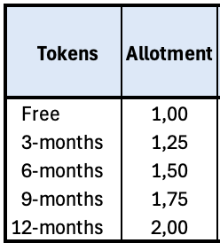

● Multi-Level Staking Programs
Different staking tiers will be introduced to offer varied rewards, risk levels, and long-term benefits.
● Passive Income & Ecosystem Stability
Staking helps maintain token stability, increase liquidity, and encourage long-term holding.
● Community-Driven Incentives
Staking aligns user interests with VaultGames' success and rewards those who commit to the ecosystem’s growth.

Why Does It Matter?
The staking mechanism ensures token utility, promotes long-term investment, and enhances the overall economic stability of VaultGames.

Token Pre-Sale Event
To ensure a fair and structured distribution of tokens, the pre-sale phase will be conducted in multiple steps, each offering a different pricing tier. This approach incentivizes early participation while maintaining a sustainable token economy. Below is a breakdown of the token allocation and pricing across the pre-sale phases.

Pre-Sale Breakdown
Pre-Sale Phase | Tokens Available | Price per Token (USD) | Total USD
Private Sale | 30,000,000 | $0.004 | $120,000
Seed Sale | 70,000,000 | $0.006 | $420,000
Flash Sale | 200,000,000 | $0.009 | $1,800,000
Step 1 | 550,000,000 | $0.018 | $9,900,000
Step 2 | 550,000,000 | $0.022 | $12,100,000
Step 3 | 550,000,000 | $0.0260 | $14,300,000
Launch Price |  | $0.0312

Pre-Sale Strategy
The VaultGames token pre-sale is designed to maximize engagement, encourage early adoption, and ensure sustainable growth. Through a structured, multi-phase approach, the pre-sale not only provides investors with strategic entry points but also strengthens the long-term stability of $VAULT´s token economy.

Benefits
● Early Adoption Incentives
VaultGames rewards early participants with lower token prices in the initial phases of the pre-sale. This incentivizes early adopters to join the ecosystem while fostering a strong community foundation. By securing tokens at a discounted rate, early investors gain a strategic advantage while contributing to the platform's initial liquidity and market presence.

● Sustainable Price Growth
To maintain a healthy and stable token economy, the pre-sale follows a tiered pricing model, where $VAULT´s price gradually increases with each phase. This prevents excessive volatility and discourages sudden price drops caused by large sell-offs post-launch. Instead, it creates a steady and organic appreciation in value to benefit both early and later-stage investors.

• Price correction
VaultGames reserves the right to change the ICO prising in step 2 and 3 based upon how the demand was in step 1, subsequently changing the price in step 3 based upon the demand during step 2.

● Strategic Funding Allocation
The funds raised during the pre-sale will be strategically distributed to key areas that drive the growth and sustainability of the VaultGames ecosystem.
➢ Liquidity Pool: Ensures smooth trading and stability in decentralized exchanges.
➢ Platform Development: Funds the enhancement of gaming infrastructure, smart contracts, and user experience.
➢ Marketing & User Acquisition: Fuels brand awareness, partnerships, and promotional campaigns to attract a global audience.
➢ Liquidity Provisioning: Strengthens token availability for seamless transactions and exchange listings.
➢ Ecosystem Growth: Supports innovation, governance initiatives, and future upgrades to expand VaultGames’ offerings.

● Community Engagement & Exclusive Rewards
Participants in the pre-sale gain access to unique benefits within the VaultGames ecosystem, including:
➢ Staking Opportunities: Pre-sale investors can stake their tokens early to earn passive rewards.
➢ Exclusive Airdrop Campaigns: Early supporters will have access to airdrops as a reward for their contribution.
➢ VIP Perks & Early Access: Investors may receive special privileges, such as early access to platform features and premium gaming experiences.

Vesting Schedule
To promote a healthy token economy and prevent excessive selling pressure, VaultGames has implemented a structured vesting schedule for its pre-sale allocations. This approach ensures a gradual release of tokens and prevents market volatility while fostering long-term commitment from investors.
By integrating a cliff and linear vesting mechanism, VaultGames aligns with industry best practices and ensures that early investors contribute to the ecosystem's growth rather than causing price instability through mass selloffs.

Breakdown of the Vesting Schedule Across Pre-Sale Phase
Private & seed sale
● Initial Release (TGE): 0 % - Cliff 6 months
● Vesting Duration: 24 months (linear vesting)
The 6-month cliff ensures that no tokens are released immediately after TGE, preventing early selloffs. After the cliff, the remaining tokens are released gradually over 24 months.

Flash Sale
● Initial Release (TGE - Token Generation Event): 15%
● Cliff Period: 2 months
● Vesting Duration: 4 months (linear vesting)
The 2-month cliff ensures that no tokens are released immediately after TGE, preventing early selloffs. After the cliff, the remaining tokens are released gradually over 4 months.
Presale Step 1
● Initial Release (TGE): 20%
● Vesting Duration: 4 months (linear vesting)
This phase follows a linear vesting model without a cliff, meaning the remaining tokens are distributed in small portions over 4 months.

Presale Step 2
● Initial Release (TGE): 20%
● Vesting Duration: 3 months (linear vesting)
Similar to Step 1, but with a shorter vesting period of 3 months that provides investors a quicker access to their holdings while maintaining price stability.

Presale Step 3
● Initial Release (TGE): 20%
● Vesting Duration: 2 months (linear vesting)
This phase introduces a more accelerated vesting schedule and balances investor liquidity while ensuring the ecosystem remains stable.

Dynamic Vesting Releases
Unlike fixed-date token unlocks that can flood the market and cause price dips, VaultGames employs a dynamic vesting model. This means:
● Tokens are released gradually over the vesting period.
● There are no single large unlock events that could trigger selloffs.
● This smooth market impact ensures price stability and sustained investor confidence.

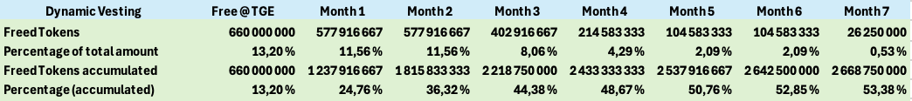

Why Does This Vesting Strategy Matter?
● Prevents Market Manipulation: Large, sudden token unlocks can lead to price crashes.
● Encourages Long-Term Participation: Investors remain engaged over time, which supports platform growth rather than quick exits.
● Supports Liquidity & Adoption: Tokens are released gradually to ensure there is enough liquidity in the market without flooding supply.
● Aligns Interests of Investors & Platform: Investors benefit from a stable ecosystem while the platform sustains steady development and adoption.

Buyback program
VaultGames has implemented a strategic Buyback Program to enhance the sustainability and long-term value of the $VAULT token. By allocating a portion of its GGR (Gross Gaming Revenue) to repurchase tokens from the market, the platform actively reduces token supply, supports valuation, and enhances investor confidence. The platform will have an automatic buyback system where tokens are bought every hour.

Core Objectives of the Buyback Program
● Supply Reduction: Reducing the circulating supply to create scarcity and increase token value.
● Market Support: Ensuring price stability by counteracting excessive selling pressure.
● Token Utility Enhancement: Strengthening the token economy by redistributing a portion of the repurchased tokens for strategic marketing initiatives.

Buyback Distribution Strategy
Once tokens are repurchased through the buyback program, they are allocated as follows:

75% Burn Mechanism
● 75% of all repurchased tokens are permanently burned (deleted) from circulation.
● This directly reduces supply which leads to increased scarcity and potential value appreciation over time.
● The burning process is fully automated & transparent and ensures fairness & accountability.

25% Marketing & Growth Initiatives
● 25% of repurchased tokens is retained for strategic marketing initiatives, including:
➢ Airdrop campaigns to attract new users.
➢ Community engagement programs to incentivize active participation.
➢ Referral & loyalty rewards to encourage long-term player retention.
● By reinvesting a portion of the buyback into marketing, VaultGames ensures continuous ecosystem growth and adoption.

Transparency & Real-Time Monitoring
To maintain full transparency and community trust, VaultGames will provide a live, real-time updated Buyback dashboard on its official website. This page will display:
● Total Tokens Purchased: A cumulative count of all repurchased $VAULT tokens.
● Detailed Purchase Records: A complete list of buyback transactions in each cycle.
● Average Purchase Price: Insights into the average price paid for token repurchases.
● Tokens Burned: A real-time count of tokens permanently removed from circulation.
● Tokens Retained for Marketing: The exact number of tokens set aside for promotional activities.

Why the Buyback Program Matters
● Enhances Token Value: By reducing circulating supply, the buyback program creates scarcity, potentially driving higher demand and value appreciation.
● Boosts Market Confidence: A structured, ongoing buyback signals strong project commitment, reassuring investors and token holders.
● Reduces Sell Pressure: Regular buybacks help counteract market fluctuations by absorbing excess token supply.
● Supports Long-Term Growth: By reinvesting a portion of tokens into marketing and ecosystem expansion, VaultGames ensures continuous user acquisition and platform engagement.

Token Utility & Dividends
The $VAULT token serves as the core utility asset within the VaultGames ecosystem that enhances both the gaming experience and the investment potential for token holders. Designed to create a self-sustaining, player-driven economy, $VAULT ensures that users are rewarded for participation, long-term engagement, and investment in the platform.
Here are the key utilities of $VAULT:
- In-Game Currency
$VAULT functions as the primary in-game currency and enables seamless transactions within the VaultGames platform. It enhances the gaming experience by offering exclusive features and rewarding active users.
Working
➢ Placing Bets & Participating in Casino Games: Players can wager in $VAULT across various casino games, including slots, poker, and sports betting.
➢ Purchasing In-Game Assets: $VAULT can be used to buy in-game assets and unlock premium features & exclusive gaming content.
➢ Exclusive Access & Premium Experiences: Players using $VAULT gain access to special tournaments, VIP tables, and high-stakes betting rooms.
➢ Rewarding Active Players: Players who engage with the platform using $VAULT tokens will receive additional rewards, such as bonus tokens, cashback, or free spins.

● Staking & Revenue Sharing
VaultGames offers a robust staking mechanism that allows $VAULT holders to earn rewards while contributing to the ecosystem’s growth.
Working
➢ Stake to Earn Rewards: Holders can stake to earn rewards in $VAULT tokens from the dedicated staking rewards pool. In a possible event where the staking pool will be fully used, VaultGames will use up to 10 % of its GGR to buy back $VAULT from the open market.
➢ Multi-Level Staking: The flexible staking model allows users to select different staking options in a single staking event while providing multiple earning opportunities.
➢ Exclusive Perks for Stakers: Stakers enjoy additional benefits, such as VIP access, lower transaction fees, and increased reward multipliers.
➢ Diversified Risk & Rewards: With multi-level staking features, users can choose different staking durations and risk levels to optimize their earnings.
● Exclusive Bonuses & Loyalty Rewards
$VAULT holders gain access to special incentives designed to reward loyalty, encourage long-term engagement, and maximize user benefits.
Working
➢ Reduced Fees & Higher Payouts: Transactions made using $VAULT will benefit from lower fees and higher payout percentages.
➢ Exclusive Promotions & Special Tournaments: Only $VAULT holders will be eligible to participate in exclusive tournaments, jackpots, and VIP events.
➢ Loyalty-Based Rewards: Frequent players using $VAULT will receive cashback incentives, free spins, and tier-based loyalty bonuses

Dividends
Holders of the Token on every last day of any quarter will receive a dividend from VaultGames based on its revenue stream. The amount will be divided differently between free tokens and tokens that are staked. Tokens in a vesting program do not qualify for dividends.
● Free tokens get a 1 to 1 ratio
● Tokens staked 3 months get a 1 to 1,25 ratio
● Tokens staked 6 months get a 1 to 1,50 ratio
● Tokens staked 9 months get a 1 to 1,75 ratio
● Tokens staked 12 months gets a 1 to 2,00 ratio.

Roadmap
The VaultGames roadmap lays out a clear path forward and highlights major milestones aimed at driving growth and engagement. With continuous upgrades, new feature implementations, strategic collaborations, and exclusive events, each stage presents fresh opportunities for innovation and expansion. Exciting announcements on platform enhancements, community-driven initiatives, and special campaigns are designed to keep the ecosystem dynamic & evolving.

Quarterly Roadmap Plan

Q4 - 2024
● Company formation
● Business plan
● Initial Financing

Q1 - 2025
● ICE Barcelona
➢ Software suppliers
➢ Marketing partners
● Finalizing gaming project plan
● ICO partner- Antier Solutions Pvt. Ltd.
● Blockchain decision - Base
● Finalizing whitepaper
➢ Tokenomics
➢ Vesting plan
➢ Staking
➢ Rakeback
➢ Buyback/Burn program
➢ Quarterly dividends to Token holders

Q2 - 2025
● Audit whitepaper
● Finalizing ICO Platform
● Acquire gaming license (Anjouan)

Q3 - 2025
● Private sale & Seed sale tokens
● Launch of Casino and Sportsbook
● Release VaultGames affiliate program (Gaming)
● Acquire gaming license (UK)
● Recruiting
● Sponsorship & sports influencers - Contract signings

Q4 - 2025
● Launch poker room
● Airdrop campaign 1/3
● Game development
● Release VaultGames affiliate program (ICO)

Q1 - 2026
● Public ICO
● Listing on Uniswap
● Airdrop campaign 2/3 & 3/3
● Introduce Rakeback program
● Promote staking program
● Launch buyback/burn program
● Lottery

Conclusion

VaultGames is at the forefront of innovation in the GameFi and crypto casino industry. By addressing the challenges of both traditional gambling platforms and existing crypto casinos, VaultGames provides a secure, efficient, and rewarding ecosystem that benefits players, investors, and stakeholders alike.
At the heart of this ecosystem lies the $VAULT token, designed to serve as the primary currency for gaming, staking, governance, and rewards. With Base blockchain as its foundation, VaultGames ensures low transaction fees, high scalability, and seamless user interactions.
The VaultGames roadmap outlines a structured approach toward long-term growth while emphasizing platform development, community engagement, and sustainable Tokenomics. From staking rewards and revenue-sharing models to buyback programs and vesting schedules, every aspect of the VaultGames ecosystem is designed to promote value retention, minimize market volatility, and maximize user benefits.
VaultGames aims to expand its offerings through strategic partnerships, exclusive gaming features, and community-driven initiatives. With a strong foundation, a visionary approach, and a passionate community, VaultGames is poised to revolutionize online gaming and bring together entertainment, innovation, and financial opportunities in a decentralized, player-first environment.

